**ACCESS SECURE TRANSFER**

Go to this URL:

<https://secure.access-k12.org>

Log in with your email credentials. Use your email alias and your email password.

Click “Sign In”

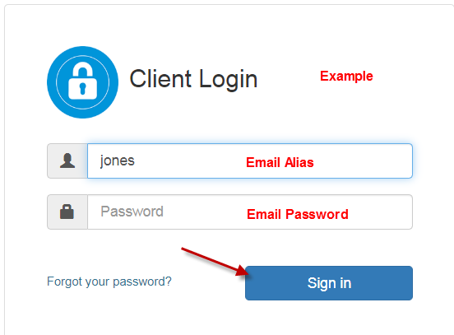

Your district folder will display with your district name abbreviation.

Click on the folder.

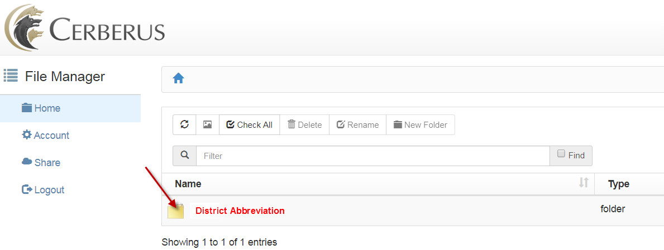

Click on 

Browse on your computer & find the file you want to transfer.

Click on it. The file name will move to the “File Name” area.

Click on “Open” (to the right)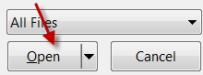

Click on “Start Upload”

This will load your file into the Secure Transfer area.

Let ACCESS know that your file has been loaded.